Index

|  |  |  |
| --- | --- | --- |
| **SL. NO** | **Table Of Content** | **Page No.** |
| **1** | **Introduction**   * 1. Introduction of the System      1. Project Title      2. Category      3. Overview      4. Background   2. Objectives of the System.   3. Scope of the System.   4. Structure of the System.   5. System Architecture   6. Software/Hardware used for the development   7. Software/Hardware required for the implementation |  |
| **2.** | **Methodology** |  |
|  | * 1. System Design      1. Functional Decomposition  1. System Software Architecture 2. System Technical Architecture 3. External Interfaces    * 1. Description of Programs 4. Context Flow Diagram (CFD) 5. Data Flow Diagrams (DFD)    1. Database Design.       1. Database Identification       2. Table Definition       3. ER Diagram    2. Detailed Design.       1. Modular decomposition of the System       2. Structure chart showing the hierarchy of modules       3. Procedural details (Flow Chart) of components |  |
| **3.** | **Analysis and Interpretation** |  |
|  | * 1. Program Code Listing   2. User Interface (Screens and Reports) |  |
|  | **Conclusion** |  |
|  | * 1. Major findings   2. Conclusion   3. Limitations   4. Suggestions / recommendations   5. Learning outcomes   6. Abbreviations and Acronyms   7. References |  |

Chapter 1

INTRODUCTION

* 1. **Introduction of the System**.

In the dynamic landscape of digital commerce, the market for watches stands out as a domain ripe for innovation and accessibility. Our project embarks on the creation of an e-commerce platform dedicated to watches, recognizing the evolving preferences and shopping behaviors of consumers in the digital age. With a focus on convenience, variety, and security, our platform aims to revolutionize the way watch enthusiasts discover, explore, and purchase timepieces online. By leveraging cutting-edge technology and user-centric design principles, we aspire to deliver an immersive and personalized shopping experience that rivals the quality and service of traditional brick-and-mortar stores. Through meticulous attention to detail and a commitment to excellence, our e-commerce website endeavors to become the go-to destination for watch aficionados, offering a curated selection of brands, styles, and features to suit every taste and preference.

**1.1.1 Project Title**

Wristwatch-Emporium

**1.1.2 Category**

Web-Based Application

**1.1.3 Overview**

The “**Wristwatch-Emporium**” aims to create a dynamic and user-friendly platform for watch enthusiasts to explore, discover, and purchase a wide range of timepieces. With a focus on quality, authenticity, and customer satisfaction, the website seeks to become a trusted destination for both seasoned collectors and casual shoppers alike.

**1.1.4 Background**

In response to the evolving dynamics of the watch industry and the increasing popularity of online shopping, our **Wristwatch Emporium** seeks to bridge the gap between traditional watch retail and modern consumer preferences. By leveraging the convenience and accessibility of online platforms, we aim to offer a diverse selection of watches from renowned brands to cater to the needs and preferences of a broad audience of watch enthusiasts and consumers. Through innovative features, strategic partnerships, and a user-friendly interface, our platform aims to become a prominent player in the online watch retail market, providing customers with a seamless and enjoyable shopping experience.

Top of Form

**Bottom of Form**

**1.2 Objectives of the System**

1. Provide a diverse range of watches from various brands, styles, and price points to cater to different customer preferences.

2. Ensure a seamless and secure online shopping experience, including user-friendly navigation, secure transactions, and reliable customer support.

3. Foster customer engagement and trust through transparent product information, reviews, and responsive communication channels.

4. Implement effective marketing strategies to increase website traffic, attract potential customers, and promote sales through targeted campaigns.

5.Optimize inventory management and order fulfillment processes to maintain adequate stock levels, minimize delays, and enhance overall operational efficiency.

**1.3 Importance and Scope of the System.**

**Wristwatch Emporium** holds significant importance in today's digital age, providing a platform to reach a global audience and operate 24/7, which surpasses the geographical and time limitations of physical stores. This continuous availability enhances customer convenience and can lead to increased sales and satisfaction. The cost-efficiency of maintaining an online store, compared to a physical one, allows for better allocation of resources towards marketing and product development. The website also facilitates the collection of valuable customer data, enabling personalized shopping experiences and targeted marketing strategies. With advanced features such as high-quality product displays, and customers can make informed purchasing decisions from the comfort of their homes. Additionally, the scope of such a system encompasses user registration, product management, inventory tracking, secure payment processing, and real-time shipping integration. It also includes robust customer support, marketing tools, and detailed analytics to guide business decisions. Security measures ensure the protection of customer data, while the system's scalability allows for future growth and integration with third-party services. Overall, an e-commerce platform for watches not only enhances the shopping experience but also provides substantial business advantages.

**1.4 Structure of the System**

The admin, service provider, and user are the three key nodes in the above structure chart. Where the administrator can manage service providers and users by logging in to the system with their username and password. Where users and service providers can sign up or log in to the system. The service provider registers, inputs, and oversees the details of his Watches. In contrast, the user registers, views the collections of watches, and schedules it based on his schedule.

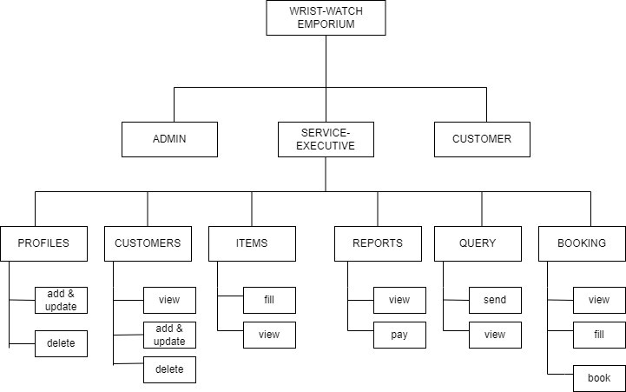

**Figure 1.1 Structure chart**

**1.5 System Architecture**

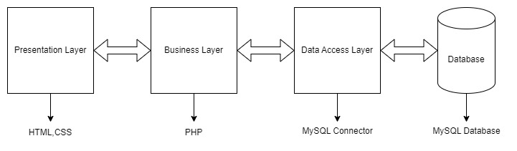

**Figure 1.2 System Software Architecture**

The above figure gives the clear picture of System Architecture. These consists of different layers Presentation Layer, Business Layer, Data Access Layer and Database.

**1.6 Software/Hardware required for the implementation.**

**1.6.1 Software Requirements (for development)**

* Server : XAMPP
* Front-End: HTML, CSS, and Bootstrap.
* Language: PHP.
* Database: MYSQL [included in XAMPP].
* Browser : Google Chrome, Opera
* Operating System : Windows 8.0 and above
* IDE : Notepad++, Visual Studio

**1.6.2 Hardware Requirements (for development)**

* RAM : 4 GB
* Hard disk : 100 GB
* Processor: Intel i3 GHz and above.

**1.6.3 Software Requirements (for implementation)**

* IDE: Visual Studio Code
* Server : XAMPP
* Database : MYSQL
* Browser: : Google Chrome, Opera

**1.6.4 Hardware Requirements (for implementation)**

* RAM: 4 GB or above
* HDD: 1 GB or above
* Operating System : Windows 8.0 and above
* Processor: Intel i3 GHz and above

Chapter 2

Methodology

**2.1 System Design**

System design translates project requirements into a well-defined architecture. It outlines the system's components, their functionalities, and how they interact. It considers scalability, performance, security, and maintainability to ensure a robust and efficient solution. This blueprint guides development and ensures all parts work together seamlessly to achieve the project's goals.

**2.1.1 Functional Decomposition**

## Functional decomposition is a method of analysis that dissects a complex process in order to examine its individual elements. A function, in this context, is a task in a larger process whereby decomposition breaks down that process into smaller, easier-to-comprehend units. In business, functional decomposition is used to facilitate the understanding and management of large and complex processes. Functional decomposition helps solve problems and aids in the development of business operations, computer programming, machine learning, and a variety of other fields

**a. System Software Architecture**

Software architecture is the high-level structure of a software system, defining its components, interactions, and guiding principles. It serves as a blueprint to manage complexity, scalability, and maintainability.

Components are the building blocks of the system, each with a specific responsibility. Connectors facilitate communication between components, such as APIs and message queues. Configurations define how components and connectors are arranged to form the system's structure.

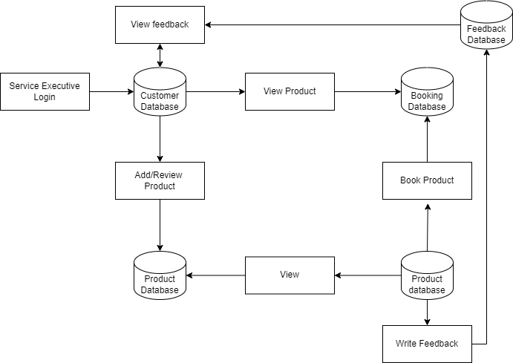 **Figure 2.1 System software Architecture**

The above figures the clear picture of system software architecture. This figure consists of Login, admin, service provider details, user details, feedback, and booking, add ev station, bills.

**b .System Technical Architecture**

Software technical architecture is the detailed design of a software system, focusing on technical aspects and their implementation. It translates high-level architectural vision into a practical plan for building the system.

Components are the individual units of the system, each with a specific function, such as user interface (UI) for user interactions, business logic for processing data, and data access layers

for database communication. Services provide reusable functionality across the system.



**Figure 2.2 System Technical Architecture**

The above figure gives the clear picture of System Architecture. These consists of different layers Presentation Layer, Business Layer, Data Access Layer and Database.

**The system is made up of four layers:**

**• The presentation layer**: Includes user interfaces built using the HTML5 and CSS tools. The interface is designed using GUI components which are user-friendly.

• **Business Logic layer**: The business logic layer, also known as the business layer or domain layer, is a crucial component of a system's technical architecture. It is responsible for encapsulating the core functional algorithms and processing logic of the application.

• **Database layer**: It is used to store data forwarded by the business layer and retrieve data on demand to the business layer. MySQL database software is used as a back-end database of the system.

**c .External Interfaces**

• User interface

By using HTML5, CSS3, bootstrap to develop rich user interface.

• Software interface

To develop this application we use the following software Notepad++/Visual Studio XAMP MYSQL server

* + 1. **Description of Programs**

**a .Context Flow Diagram**

Context flow diagram is a top level (also known as level 0) data flow diagram. It contains only one process node that generalizes the functions of the entire system in relationship to external entities. In context diagram the entire system is treated as single process and all its inputs, outputs, sinks and sources are identified and shown below. It only contains one process node (process 0) that generalizes function of the entire system in relationship to external entities. In context diagram the entire system is created as a single process and all its inputs, outputs, sinks and sources are identified and shown.

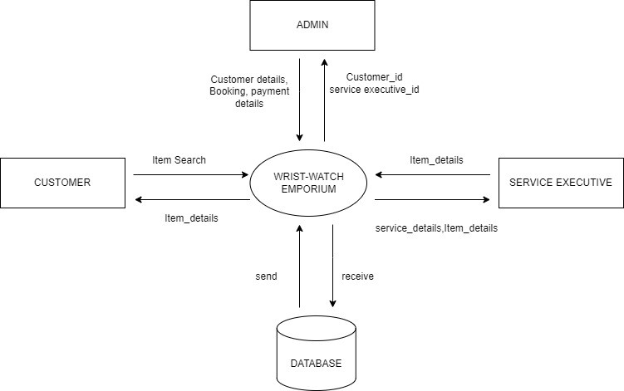

**Figure 2.3 Context flow diagram**

**b. Data Flow Diagrams**

A Data flow diagram is a graphical representation of the flow of data through an information system. A data flow diagram can also be used for the visualization of the data processing. It is common practice for a designer to draw a context level DFD. It shows the interaction between the system and the outside entities. This context level DFD, is then exploded to show more detail of the system being modelled.

**Top Level DFD**

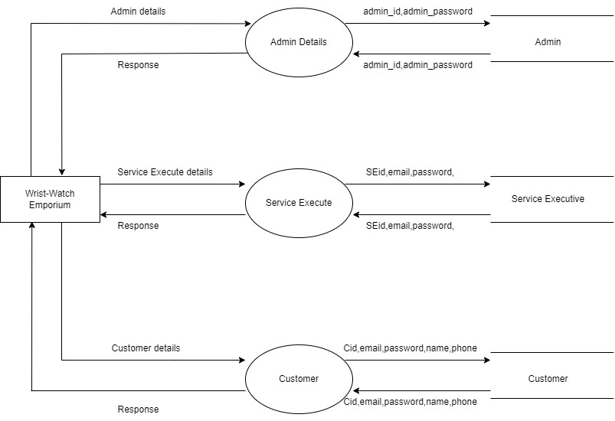

**Figure 2.4 top level dfd**

Data Flow Diagram is a graphical representation of a system or a portion of the system. It consists of data flows, process, sources and sink and stores all the description through the use of easily understandable symbols. DFD is one of the most important modelling tools. It is used to model the system, components that interact with the system, uses the data and information flows in the system.

**Level 1 DFD (Admin):**

In 1-level DFD, the context diagram is decomposed into multiple bubbles/processes. In this level, we highlight the main functions of the system and breakdown the high-level process of 0-level DFD into sub processes.

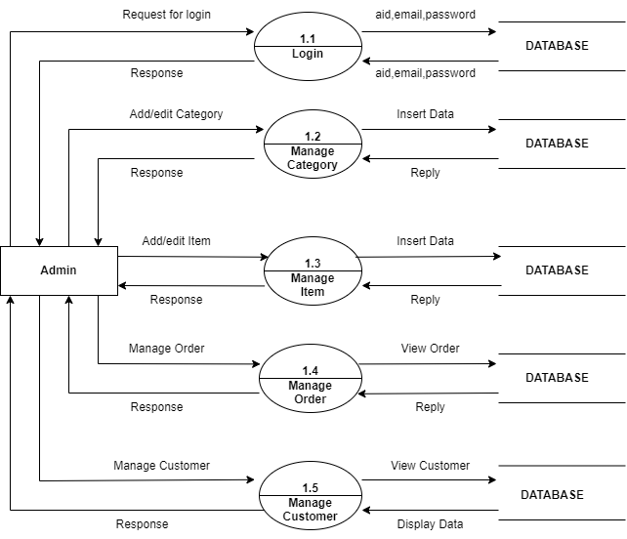

**Figure 2.5 DFD level 1(admin)**

In the above diagram, admin logs in and manages customer, items, and also views feedback.

**Level 1 DFD (Customer):**

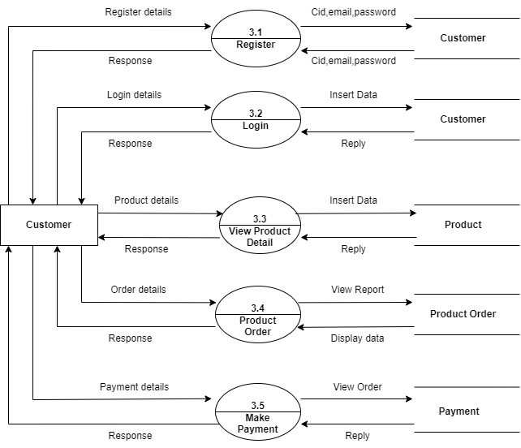

**Figure 2.6 DFD Levels 1 (user)**

In the project Wristwatch Emporium, user registers or login and view the website, if the booking is allowed it books a slot and payment is done at the end user gives feedback.

**Level 1 DFD (Service Provider):**

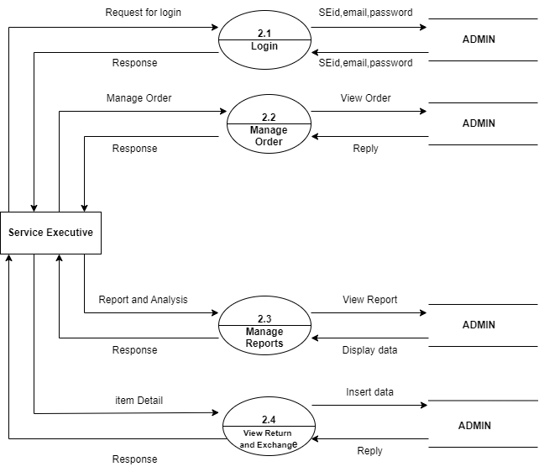

**Figure 2.7 DFD Levels 1 (service provider)**

In the project Wristwatch Emporium, service provider registers or login and views the user.

**Database Design**

Microsoft SQL Server is a full-featured relational database management system (RDBMS) that offers a variety of administrative tools to case the burdens of database development maintenance and administration. In this article, we'll cover six of the more frequently used tools Enterprise Manager, Query Analyzer, SQL Profiler Service Manager, Data Transformation Services and Books Online. Enterprise Manager is the main administrative console for SQL Server installations. It provides you with a graphical "birds-eye" view of all of the SQL Server installations on your network. You can perform high-level administrative functions that affect one or more servers, schedule common maintenance or create and modify the structure of individual data bases. Query Analyzer offers a quick and dirty method for performing queries against any of your SQL Server databases. It's a great way to quickly pull information out of a database in response to a user request, test queries before implementing them in other applications, create/modify stored procedures and execute administrative tasks SQL Profiler provides a window into the inner workings of your database You can monitor many different event types and observe database performance in real can monitor many different event types and observe database performance in real time SQL Profiler allows you to capture and replay system "traces" that log various activities. It's a great tool for optimizing databases with performance issues or troubleshooting particular problems.

**2.2.1 Database Identification**

Database identification in a project refers to the process of determining the specific database system that will be used to store and manage the project's data.

**Database**

* Admin: It contains login details of admin.
* Service: It contains registration and login details of service provider.
* User: It contains registration and login details of user.
* Bill: It contains billing details.
* Order: It contains order details.
* Feedback: It contains details of user feedback.

**2.2.2 Table Definition**

#### **Admin**

|  |  |  |  |  |
| --- | --- | --- | --- | --- |
| Column Name | Type | Constraints | Description | Example |
| admin_id | INT (10) | Not Null | Primary Key. Auto-generated identifier. | 123 |
| admin_email | VARCHAR (60) | Not Null | Email of the admin. | Litheshpa80@gmail.com |
| admin_username | VARCHAR (20) | Not Null | Username of the admin. | Lithesh |
| admin_password | VARCHAR (10) | Not Null | Password for admin login. | 87357239 |

**Table 2.1 admin**

**Service Provider**

|  |  |  |  |  |
| --- | --- | --- | --- | --- |
| Column Name | Type | Constraints | Description | Example |
| executive_id | INT (10) | Not Null | ID Required. Primary Key. Auto-generated. | 321 |
| executive_name | VARCHAR (60) | Not Null | Name Required. Stores executive name. | sushrith@gmail.com |
| email | VARCHAR (20) | Not Null | Email Required. Stores executive email. | Sushrith |
| phone | INT(10) | Not Null | Phone Required. Stores executive phone number. | 87357239 |

**Table 2.2 Service Provider**

## Customer Table

|  |  |  |  |  |
| --- | --- | --- | --- | --- |
| Column Name | Type | Constraints | Description | Example |
| customer_id | Int (10) | Not Null | ID Required. Primary Key. Auto-generated. | 4543 |
| customer_name | Varchar(60) | Not Null | Name Required. Stores customer name. | hushrith@gmail.com |
| email | Varchar(60) | Not Null | Email Required. Stores customer email. | hushrith |
| phone | Varchar(20) | Not Null | Phone Required. Stores customer phone number. | 87357239 |

**Table2. 3 Customer**

## Service Request

|  |  |  |  |  |
| --- | --- | --- | --- | --- |
| Column Name | Type | Constraints | Description | Example |
| request_id | Int (10) | Not Null | ID Required. Primary Key. Auto-generated. | 4543 |
| customer_id | Int (10) | Not Null | Customer ID Required. Foreign key. | 123 |
| executive_id | Int (10) | Not Null | Executive ID Required. Foreign key. | 4321 |
| request_date | Date | Not Null | Date Required. Stores request date. | 22/07/2022 |
| status | Varchar(20) | Not Null | Status Required. Stores request status. | processing |
| details | Text | Not Null | Details Required. Stores service request details. | Hp Lap |

**Table 2.4 Service Request**

## Payment Table

|  |  |  |  |  |
| --- | --- | --- | --- | --- |
| Column Name | Type | Constraints | Description | Example |
| payment_id | Int (10) | Not Null | ID Required. Primary Key. Auto-generated. | 4543 |
| request_id | Int (10) | Not Null | Request ID Required. Foreign key. | Hhcsasabasb33321 |
| payment_date | Date | Not Null | Date Required. Stores payment date. | 22/07/2022 |
| amount | Decimal(10,2) | Not Null | Amount Required. Stores payment amount. | 2000 |
| payment_method | Varchar(20) | Not Null | Method Required. Stores payment method. | Paytm |

**Table 2.5 Payment table**

### Notification Table

|  |  |  |  |  |
| --- | --- | --- | --- | --- |
| Column Name | Type | Constraints | Description | Example |
| notification_id | Int (10) | Not Null | ID Required. Primary Key. Auto-generated. | 7463 |
| customer_id | Int (10) | Not Null | Customer ID Required. Foreign key. | 123 |
| message | Text | Not Null | Message Required. Stores notification message. | successfull |
| date | Date | Not Null | Date Required. Stores notification date. | 22/072022 |

**Table 2.6 Notification table**

**2.2.3 ER diagram**

Entity relationship diagram is used in modern database software engineering to illustrate logical structure of database. It is a relational schema database modelling method used to model a system and approach. This approach is commonly used in database design. The diagram created using this method is called the E-R diagram.

An entity-relationship (ER) diagram is a specialized graphic that illustrates the relationships between entities in a database. ER diagrams often use symbols to represent three different types of information. Boxes are commonly used to represent entities. Diamonds are normally used to represent relationships and ovals are used to represent attributes.

**Entity:**

Entity is represented by a box within the ER Diagram. Entities are abstract concepts, each representing one or more instances of the concept in question. An entity might be considered a container that holds all of the instances of a particular thing in a system. Entities are equivalent to database tables in a relational database, with each row of the table representing an instance of that entity.

**Relationship:**

Relationships are represented by Diamonds. A relationship is a named collection or association between entities or used to relate to two or more entities with some common attributes or meaningful interaction between the objects.

**Attributes:**

Attributes are represented by Oval. An attribute is a single data item related to a database object. The database schema associates one or more attributes with each database entity.

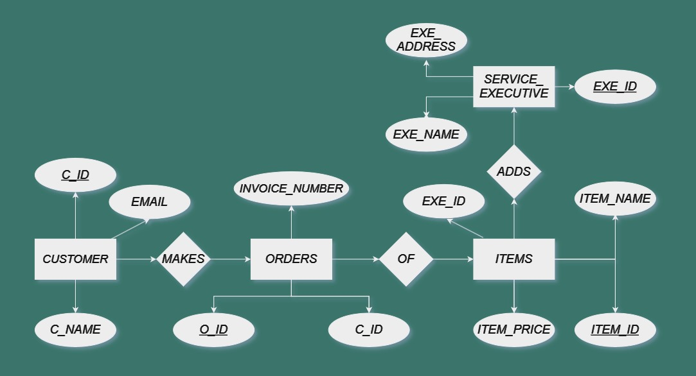

**Figure 2.8 ER diagram**

**2.3 Detailed Design**

System design is the process of defining the architecture, modules, interfaces, and data for a system to satisfy specified requirements. System design could be seen as the application of systems theory to product development.

**2.3.1Modular decomposition of the System**

Modular decomposition is the process of breaking down a system into smaller, manageable modules or components. It helps in understanding and managing complex systems by dividing them into more understandable and independent parts. Each module typically performs a specific function and can be developed, tested, and maintained independently, which improves flexibility, scalability, and maintainability of the overall system.

**2.3.2 Structure chart showing the hierarchy of modules**

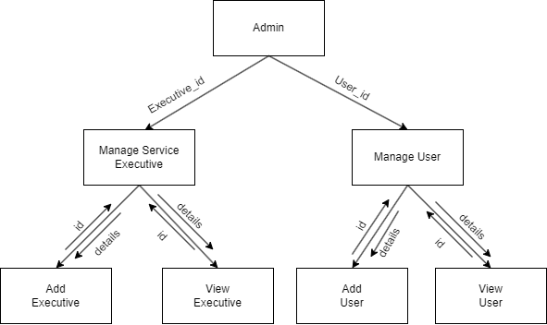

**Figure 2.9 Structure chart of the Admin Login**

### Data Structures shared among module

* Service provider
* User

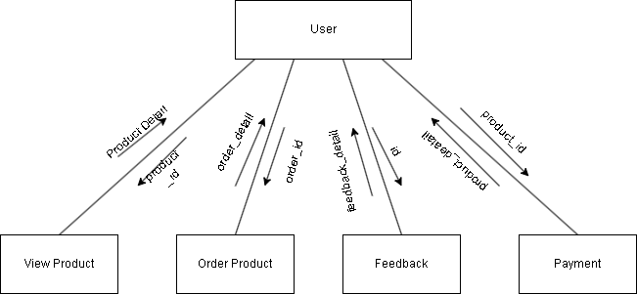

**Figure 2.10 Structure chart of the user**

### Data Structures shared among modules

* + - * + Feedback
        + Booking
        + Payment

**2.3.3 Procedural details (Flow Chart) of components**

**Admin login**

**Inputs:**  username, password

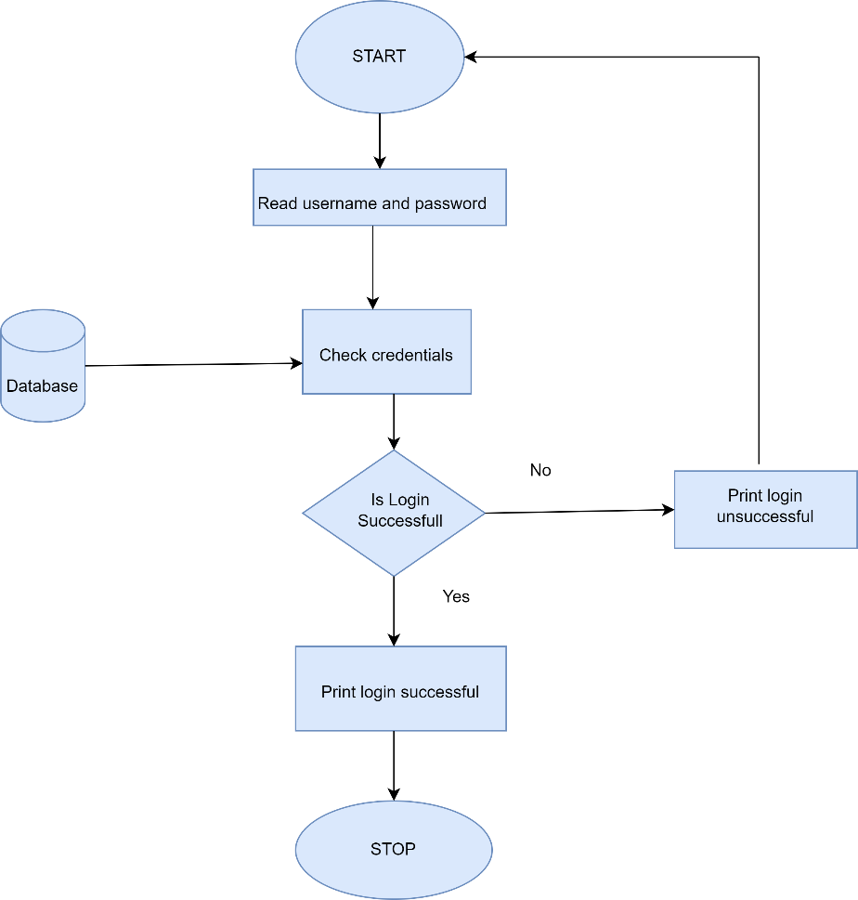

**Figure 2.12 flow chart of the admin login**

**Manage Service Executive**

**Inputs:** spid, username, email,password

## 

**Figure 2.13 flow chart of the service provider**

**Manage Customer**

**Inputs:** uid, name, password, email.

## 

## Figure 2.14 flow chart of the user

###### **Registration**

**Inputs**: Name, phone, address, email id, password

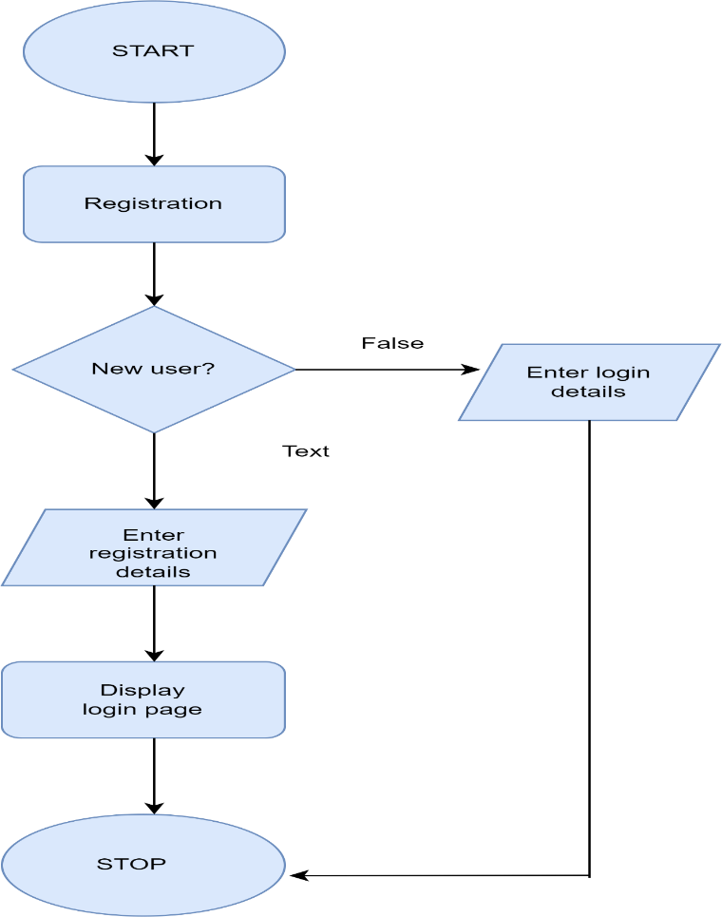

## 

## Figure 2.15 flow chart of the customer Registration

###### **Login**

**Inputs:** The Customer enters Username and Password

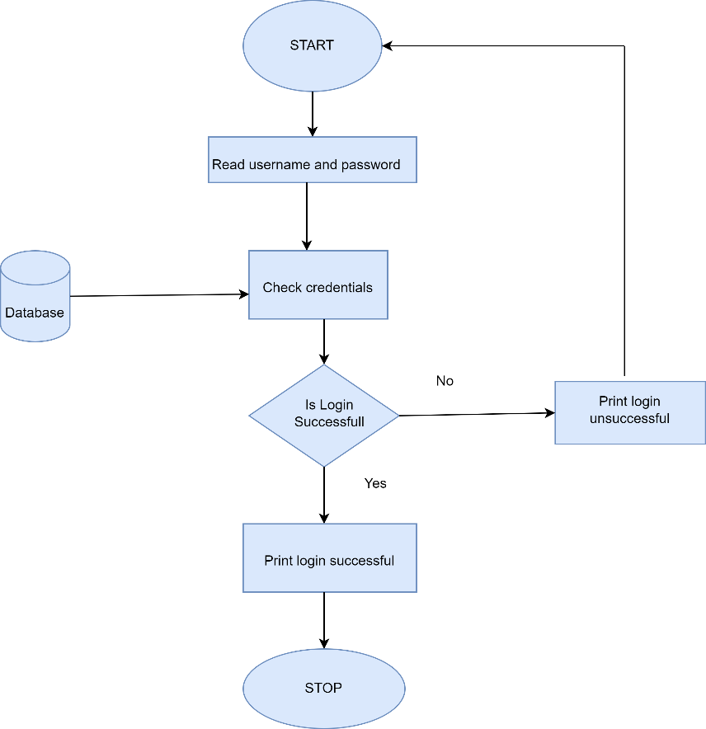

## Figure 2.16 flow chart of Customer login

###### **Add Product**

**Inputs**: Admin can add Products or delete the Products

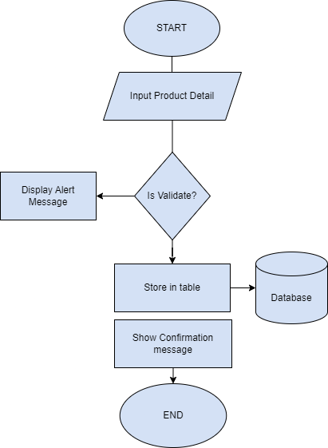

## Figure 2.17 flow chart of the add product

###### **View feedback**

**Inputs**: The owner can view the Feedback of the User.

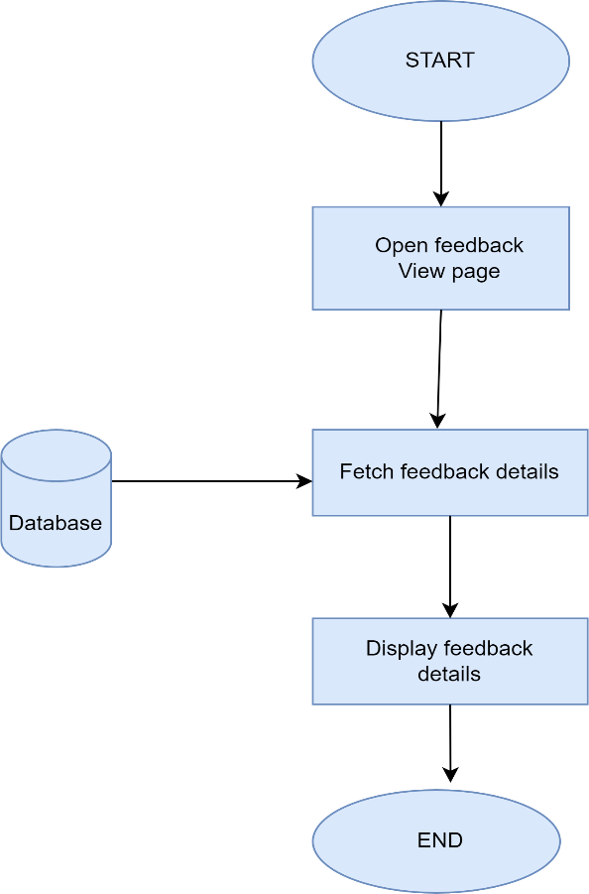

## Figure 2.16 flow chart of Feedback

###### **Payment**

**Inputs**: payment_id

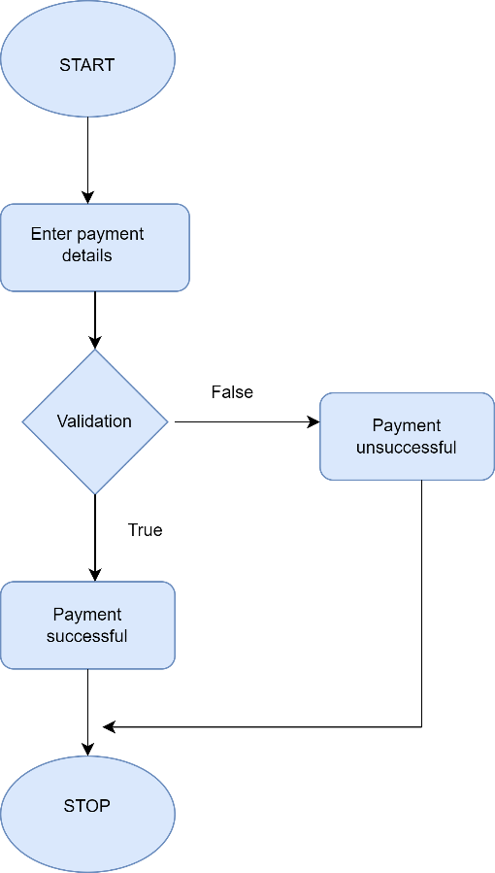

## Figure 2.17 flow chart of the payment

File I/O interface: Payment table

Output: Here Customers can do his payments.

###### **Add Feedback**

**Inputs**: f_id

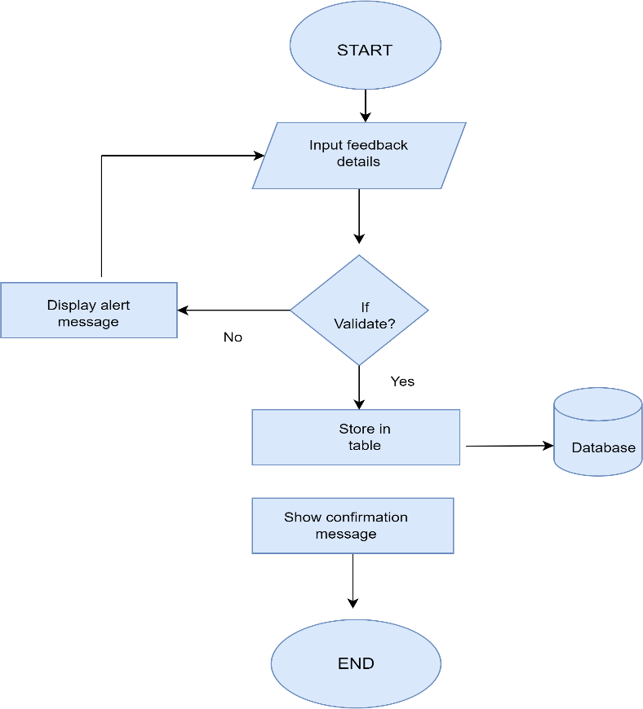

## Figure 2.18 flow chart of adding feedback

Chapter 3

Analysis and Interpretation

**3.1 Program code listing**

**User Login**

<?php

session_start();

if (isset($_SESSION["user"])) {

header("Location: index.php");

}

?>

<!DOCTYPE html>

<html lang="en">

<head>

<meta charset="UTF-8">

<meta http-equiv="X-UA-Compatible" content="IE=edge">

<meta name="viewport" content="width=device-width, initial-scale=1.0">

<title>Login Form</title>

<link rel="stylesheet" href="https://cdn.jsdelivr.net/npm/bootstrap@5.2.2/dist/css/bootstrap.min.css" integrity="sha384-Zenh87qX5JnK2Jl0vWa8Ck2rdkQ2Bzep5IDxbcnCeuOxjzrPF/et3URy9Bv1WTRi" crossorigin="anonymous">

<link rel="stylesheet" href="P1_loginpage.css">

<style>

.container

{

margin-top:20%;

}

</style>

</head>

<body>

<div class="container">

<?php

if (isset($_POST["login"])) {

$email = $_POST["email"];

$password = $_POST["password"];

require_once "database.php";

$sql = "SELECT * FROM users WHERE email = '$email'";

$result = mysqli_query($conn, $sql);

$user = mysqli_fetch_array($result, MYSQLI_ASSOC);

if ($user) {

if (password_verify($password, $user["password"])) {

session_start();

$_SESSION["user"] = "yes";

header("Location:index.html");

die();

}else{

echo "<div class='alert alert-danger'>Password does not match</div>";

}

}else{

echo "<div class='alert alert-danger'>Email does not match</div>";

}

}

?>

<form action="login.php" method="post">

<div class="form-group">

<input type="email" placeholder="Enter Email:" name="email" class="form-control">

</div>

<div class="form-group">

<input type="password" placeholder="Enter Password:" name="password" class="form-control">

</div>

<div class="form-btn">

<input type="submit" value="Login" name="login" class="btn btn-primary">

</div>

</form>

<div><p>Not registered yet <a href="registration.php">Register Here</a></p></div>

</div>]

</body>

</html>

**Index**

<!DOCTYPE html>

<html lang="en">

<head>

<meta charset="UTF-8">

<meta name="viewport" content="width=device-width, initial-scale=1.0">

<!--=============== FAVICON ===============-->

<link rel="shortcut icon" href="assets/img/favicon.png" type="image/x-icon">

<!--=============== BOXICONS ===============-->

<link rel="stylesheet" href="https://cdn.jsdelivr.net/npm/boxicons@latest/css/boxicons.min.css">

<!--=============== SWIPER CSS ===============-->

<link rel="stylesheet" href="assets/css/swiper-bundle.min.css">

<!--=============== CSS ===============-->

<link rel="stylesheet" href="assets/css/styles.css">

<title>Responsive watches website - Bedimcode</title>

<link rel="stylesheet" href="index.css">

</head>

<body>

<!--==================== HEADER ====================-->

<header class="header" id="header">

<nav class="nav container">

<a href="#" class="nav__logo">

<i class='bx bxs-watch nav__logo-icon'></i>Wrist-Watch<br>&nbsp;&nbsp;&nbsp;Emporium

</a>

<div class="nav__menu" id="nav-menu">

<ul class="nav__list">

<li class="nav__item">

<a href="#home" class="nav__link active-link">Home</a>

</li>

<li class="nav__item">

<a href="#featured" class="nav__link">Featured</a>

</li>

<li class="nav__item">

<a href="#products" class="nav__link">Products</a>

</li>

<li class="nav__item">

<a href="#new" class="nav__link">New</a>

</li>

<!-- Admin button -->

<li class="nav__item">

<a href="admin-login.php" class="nav__link">Admin</a>

</li>

</ul>

<div class="nav__close" id="nav-close">

<i class='bx bx-x' ></i>

</div>

</div>

<div class="nav__btns">

<!-- Theme change button -->

<i class='bx bx-moon change-theme' id="theme-button"></i>

<div class="nav__shop" id="cart-shop">

<i class='bx bx-shopping-bag' ></i>

</div>

<div class="nav__toggle" id="nav-toggle">

<i class='bx bx-grid-alt' ></i>

</div>

</div>

</nav>

</header>

<!--==================== MAIN ====================-->

<main class="main">

<!--==================== HOME ====================-->

<section class="home" id="home">

<div class="home__container container grid">

<div class="home__img-bg">

<img src="assets/img/home.png" alt="" class="home__img">

</div>

<div class="home__data">

<h1 class="home__title">NEW WATCH <br> COLLECTIONS B720</h1>

<p class="home__description">

Latest arrival of the new imported watches of the B720 series,

with a modern and resistant design.

</p>

<span class="home__price">₹6999</span>

<div class="home__btns">

<a href="#" class="button button--gray button--small">

Discover

</a>

<a href="buy.html" ><button class="button home__button">BUY</button></a>

</div>

</div>

</div>

</section>

<!--==================== FEATURED ====================-->

<section class="featured section container" id="featured">

<h2 class="section__title">

Featured

</h2>

<div class="featured__container grid">

<article class="featured__card">

<span class="featured__tag">Sale</span>

<img src="assets/img/featured1.png" alt="" class="featured__img">

<div class="featured__data">

<h3 class="featured__title">Jazzmaster</h3>

<span class="featured__price">₹1599</span>

</div>

<a href="buy.html" ><button class="button featured__button" data-name="Jazzmaster" data-price="₹1599">BUY</button></a>

</article>

<article class="featured__card">

<span class="featured__tag">Sale</span>

<img src="assets/img/featured2.png" alt="" class="featured__img">

<div class="featured__data">

<h3 class="featured__title">Ingersoll</h3>

<span class="featured__price">₹2299</span>

</div>

<a href="buy.html" ><button class="button featured__button" data-name="Ingersoll" data-price="₹2299">BUY</button></a>

</article>

<article class="featured__card">

<span class="featured__tag">Sale</span>

<img src="assets/img/featured3.png" alt="" class="featured__img">

<div class="featured__data">

<h3 class="featured__title">Rose gold</h3>

<span class="featured__price">₹999</span>

</div>

<a href="buy.html" ><button class="button featured__button" data-name="Rose gold" data-price="₹999">BUY</button></a>

</article>

</div>

</section>

<!--==================== STORY ====================-->

<section class="story section container">

<div class="story__container grid">

<div class="story__data">

<h2 class="section__title story__section-title">

Our Story

</h2>

<h1 class="story__title">

Inspirational Watch of <br> this year

</h1>

<p class="story__description">

The latest and modern watches of this year, is available in various

presentations in this store, discover them now.

</p>

<a href="#" class="button button--small">Discover</a>

</div>

<div class="story__images">

<img src="assets/img/story.png" alt="" class="story__img">

<div class="story__square"></div>

</div>

</div>

</section>

<!DOCTYPE html>

<html lang="en">

<head>

<meta charset="UTF-8">

<meta name="viewport" content="width=device-width, initial-scale=1.0">

<title>Products</title>

<link rel="stylesheet" href="assets/css/styles.css">

</head>

<body>

<!--==================== PRODUCTS ====================-->

<section class="products section container" id="products">

<h2 class="section__title">

Products

</h2>

<div class="products__container grid">

<article class="products__card">

<img src="assets/img/product1.png" alt="" class="products__img">

<h3 class="products__title">Spirit rose</h3>

<span class="products__price">₹2399</span>

<div class="products__buttons">

<button class="products__button">

<i class='bx bx-shopping-bag'></i>

</button>

<a href="buy.html" > <button class="products__buy-button" data-name="Spirit rose" data-price="₹2399">Buy</button></a>

</div>

</article>

<article class="products__card">

<img src="assets/img/product2.png" alt="" class="products__img">

<h3 class="products__title">Khaki pilot</h3>

<span class="products__price">₹1799</span>

<div class="products__buttons">

<button class="products__button">

<i class='bx bx-shopping-bag'></i>

</button>

<a href="buy.html" ><button class="products__buy-button" data-name="Khaki pilot" data-price="₹1799">Buy</button></a>

</div>

</article>

<article class="products__card">

<img src="assets/img/product3.png" alt="" class="products__img">

<h3 class="products__title">Jubilee black</h3>

<span class="products__price">₹4999</span>

<div class="products__buttons">

<button class="products__button">

<i class='bx bx-shopping-bag'></i>

</button>

<a href="buy.html" ><button class="products__buy-button" data-name="Jubilee black" data-price="₹4999">Buy</button></a>

</div>

</article>

<article class="products__card">

<img src="assets/img/product4.png" alt="" class="products__img">

<h3 class="products__title">Fosil me3</h3>

<span class="products__price">₹3499</span>

<div class="products__buttons">

<button class="products__button">

<i class='bx bx-shopping-bag'></i>

</button>

<a href="buy.html" ><button class="products__buy-button" data-name="Fosil me3" data-price="₹3499">Buy</button></a>

</div>

</article>

<article class="products__card">

<img src="assets/img/product5.png" alt="" class="products__img">

<h3 class="products__title">Duchen</h3>

<span class="products__price">₹2999</span>

<div class="products__buttons">

<button class="products__button">

<i class='bx bx-shopping-bag'></i>

</button>

<a href="buy.html" ><button class="products__buy-button" data-name="Duchen" data-price="₹2999">Buy</button></a>

</div>

</article>

</div>

</section>

<!--==================== TESTIMONIAL ====================-->

<section class="testimonial section container">

<div class="testimonial__container grid">

<div class="swiper testimonial-swiper">

<div class="swiper-wrapper">

<div class="testimonial__card swiper-slide">

<div class="testimonial__quote">

<i class='bx bxs-quote-alt-left' ></i>

</div>

<p class="testimonial__description">

They are the best watches that one acquires, also they are always with the latest

news and trends, with a very comfortable price and especially with the attention

you receive, they are always attentive to your questions.

</p>

<h3 class="testimonial__date">March 27. 2022</h3>

<div class="testimonial__perfil">

<img src="assets/img/testimonial1.jpg" alt="" class="testimonial__perfil-img">

<div class="testimonial__perfil-data">

<span class="testimonial__perfil-name">Lee Doe</span>

<span class="testimonial__perfil-detail">Director of a company</span>

</div>

</div>

</div>

<div class="testimonial__card swiper-slide">

<div class="testimonial__quote">

<i class='bx bxs-quote-alt-left' ></i>

</div>

<p class="testimonial__description">

They are the best watches that one acquires, also they are always with the latest

news and trends, with a very comfortable price and especially with the attention

you receive, they are always attentive to your questions.

</p>

<h3 class="testimonial__date">March 27. 2023</h3>

<div class="testimonial__perfil">

<img src="assets/img/testimonial2.jpg" alt="" class="testimonial__perfil-img">

<div class="testimonial__perfil-data">

<span class="testimonial__perfil-name">Samantha Mey</span>

<span class="testimonial__perfil-detail">Director of a company</span>

</div>

</div>

</div>

<div class="testimonial__card swiper-slide">

<div class="testimonial__quote">

<i class='bx bxs-quote-alt-left' ></i>

</div>

<p class="testimonial__description">

They are the best watches that one acquires, also they are always with the latest

news and trends, with a very comfortable price and especially with the attention

you receive, they are always attentive to your questions.

</p>

<h3 class="testimonial__date">March 27. 2023</h3>

<div class="testimonial__perfil">

<img src="assets/img/testimonial3.jpg" alt="" class="testimonial__perfil-img">

<div class="testimonial__perfil-data">

<span class="testimonial__perfil-name">Raul Zaman</span>

<span class="testimonial__perfil-detail">Director of a company</span>

</div>

</div>

</div>

</div>

<div class="swiper-button-next">

<i class='bx bx-right-arrow-alt' ></i>

</div>

<div class="swiper-button-prev">

<i class='bx bx-left-arrow-alt' ></i>

</div>

</div>

<div class="testimonial__images">

<div class="testimonial__square"></div>

<img src="assets/img/testimonial.png" alt="" class="testimonial__img">

</div>

</div>

</section>

<!--==================== NEW ====================-->

<section class="new section container" id="new">

<h2 class="section__title">

New Arrivals

</h2>

<div class="new__container">

<div class="swiper new-swiper">

<div class="swiper-wrapper">

<article class="new__card swiper-slide">

<span class="new__tag">New</span>

<img src="assets/img/new1.png" alt="" class="new__img">

<div class="new__data">

<h3 class="new__title">Longines rose</h3>

<span class="new__price">₹4000</span>

</div>

<a href="buy.html" ><button class="button new__button" data-name="Longines rose" data-price="₹4000">BUY</button></a>

</article>

<article class="new__card swiper-slide">

<span class="new__tag">New</span>

<img src="assets/img/new2.png" alt="" class="new__img">

<div class="new__data">

<h3 class="new__title">Jazzmaster</h3>

<span class="new__price">₹2499</span>

</div>

<a href="buy.html" ><button class="button new__button" data-name="Jazzmaster" data-price="₹2499">BUY</button></a>

</article>

<article class="new__card swiper-slide">

<span class="new__tag">New</span>

<img src="assets/img/new3.png" alt="" class="new__img">

<div class="new__data">

<h3 class="new__title">Dreyfuss gold</h3>

<span class="new__price">₹2599</span>

</div>

<a href="buy.html" ><button class="button new__button" data-name="Dreyfuss gold" data-price="₹2599">BUY</button></a>

</article>

<article class="new__card swiper-slide">

<span class="new__tag">New</span>

<img src="assets/img/new4.png" alt="" class="new__img">

<div class="new__data">

<h3 class="new__title">Portuguese rose</h3>

<span class="new__price">₹1999</span>

</div>

<a href="buy.html" ><button class="button new__button" data-name="Portuguese rose" data-price="₹1999">BUY</button></a>

</article>

</div>

</div>

</div>

</section>

<!--==================== NEWSLETTER ====================-->

<section class="newsletter section container">

<div class="newsletter__bg grid">

<div>

<h2 class="newsletter__title">Subscribe us <br> for awesome<br>Offers</h2>

<p class="newsletter__description">

Don't miss out on your discounts. Subscribe to our email

newsletter to get the best offers, discounts, coupons,

gifts and much more.

</p>

</div>

<form action="" class="newsletter__subscribe">

<input type="email" placeholder="Enter your email" class="newsletter__input">

<button class="button">

SUBSCRIBE

</button>

</form>

</div>

</section>

</main>

<!--==================== FOOTER ====================-->

<footer class="footer section">

<div class="footer__container container grid">

<div class="footer__content">

<h3 class="footer__title">Our information</h3>

<ul class="footer__list">

<li>Malleshwaram, Bangalore-560006</li>

<li>+91-8095737207</li>

<li>wwe@gmail.com</li>

</ul>

</div>

<div class="footer__content">

<h3 class="footer__title">About Us</h3>

<ul class="footer__links">

<li>

<a href="#" class="footer__link">Support Center</a>

</li>

<li>

<a href="#" class="footer__link">Customer Support</a>

</li>

<li>

<a href="#" class="footer__link">About Us</a>

</li>

<li>

<a href="#" class="footer__link">Copy Right</a>

</li>

</ul>

</div>

<div class="footer__content">

<h3 class="footer__title">Product</h3>

<ul class="footer__links">

<li>

<a href="#" class="footer__link">Smart Watches</a>

</li>

<li>

<a href="#" class="footer__link">Retro Watches</a>

</li>

<li>

<a href="#" class="footer__link">Hybrid Watches</a>

</li>

<li>

</ul>

</div>

<div class="footer__content">

<h3 class="footer__title">Social</h3>

<ul class="footer__social">

<a href="https://www.facebook.com/" target="_blank" class="footer__social-link">

<i class='bx bxl-facebook'></i>

</a>

<a href="https://twitter.com/" target="_blank" class="footer__social-link">

<i class='bx bxl-twitter' ></i>

</a>

<a href="https://www.instagram.com/" target="_blank" class="footer__social-link">

<i class='bx bxl-instagram' ></i>

</a>

</ul>

</div>

</div>

<span class="footer__copy">&#169; Bedimcode. All rigths reserved</span>

</footer>

<!--=============== SCROLL UP ===============-->

<a href="#" class="scrollup" id="scroll-up">

<i class='bx bx-up-arrow-alt scrollup__icon' ></i>

</a>

<!--=============== SWIPER JS ===============-->

<script src="assets/js/swiper-bundle.min.js"></script>

<!--=============== MAIN JS ===============-->

<script src="assets/js/main.js"></script>

<script src="https://js.stripe.com/v3/"></script>

<script>

document.querySelectorAll('.home__button, .featured__button, .products__buy-button, .new__button').forEach(button => {

button.addEventListener('click', async (event) => {

const name = event.target.getAttribute('data-name');

const price = event.target.getAttribute('data-price');

const response = await fetch('/create-checkout-session', {

method: 'POST',

headers: {

'Content-Type': 'application/json',

},

body: JSON.stringify({ name, price }),

});

const session = await response.json();

const stripe = Stripe('your_stripe_publishable_key');

const { error } = await stripe.redirectToCheckout({ sessionId: session.id });

if (error) {

console.error("Error redirecting to checkout:", error);

}

});

});

</script>

</body>

</html>

**Register**

<!DOCTYPE html>

<html lang="en">

<head>

<meta charset="UTF-8">

<meta http-equiv="X-UA-Compatible" content="IE=edge">

<meta name="viewport" content="width=device-width, initial-scale=1.0">

<title>Registration Form</title>

<link rel="stylesheet" href="https://cdn.jsdelivr.net/npm/bootstrap@5.2.2/dist/css/bootstrap.min.css" integrity="sha384-Zenh87qX5JnK2Jl0vWa8Ck2rdkQ2Bzep5IDxbcnCeuOxjzrPF/et3URy9Bv1WTRi" crossorigin="anonymous">

<link rel="stylesheet" href="style.css">

</head>

<body>

<div class="container">

<?php

if (isset($_POST["submit"])) {

$fullName = $_POST["fullname"];

$email = $_POST["email"];

$password = $_POST["password"];

$passwordRepeat = $_POST["repeat_password"];

$passwordHash = password_hash($password, PASSWORD_DEFAULT);

$errors = array();

if (empty($fullName) OR empty($email) OR empty($password) OR empty($passwordRepeat)) {

array_push($errors,"All fields are required");

}

if (!filter_var($email, FILTER_VALIDATE_EMAIL)) {

array_push($errors, "Email is not valid");

}

if (strlen($password)<8) {

array_push($errors,"Password must be at least 8 charactes long");

}

if ($password!==$passwordRepeat) {

array_push($errors,"Password does not match");

}

require_once "database.php";

$sql = "SELECT * FROM users WHERE email = '$email'";

$result = mysqli_query($conn, $sql);

$rowCount = mysqli_num_rows($result);

if ($rowCount>0) {

array_push($errors,"Email already exists!");

}

if (count($errors)>0) {

foreach ($errors as $error) {

echo "<div class='alert alert-danger'>$error</div>";

}

}else{

$sql = "INSERT INTO users (full_name, email, password) VALUES ( ?, ?, ? )";

$stmt = mysqli_stmt_init($conn);

$prepareStmt = mysqli_stmt_prepare($stmt,$sql);

if ($prepareStmt) {

mysqli_stmt_bind_param($stmt,"sss",$fullName, $email, $passwordHash);

mysqli_stmt_execute($stmt);

echo "<div class='alert alert-success'>You are registered successfully.</div>";

}else{

die("Something went wrong");

}

}

}

?>

<form action="registration.php" method="post">

<div class="form-group">

<input type="text" class="form-control" name="fullname" placeholder="Full Name:">

</div>

<div class="form-group">

<input type="email" class="form-control" name="email" placeholder="Email:">

</div>

<div class="form-group">

<input type="password" class="form-control" name="password" placeholder="Password:">

</div>

<div class="form-group">

<input type="password" class="form-control" name="repeat_password" placeholder="Repeat Password:">

</div>

<div class="form-btn">

<input type="submit" class="btn btn-primary" value="Register" name="submit">

</div>

</form>

<div>

<div><p>Already Registered <a href="login.php">Login Here</a></p></div>

</div>

</div>

</body>

</html>

**Admin**

<!DOCTYPE html>

<html lang="en">

<head>

<meta charset="UTF-8">

<meta name="viewport" content="width=device-width, initial-scale=1.0">

<title>Admin Dashboard</title>

<link rel="stylesheet" href="admin.css">

<!--=============== FAVICON ===============-->

<link rel="shortcut icon" href="assets/img/favicon.png" type="image/x-icon">

<!--=============== BOXICONS ===============-->

<link rel="stylesheet" href="https://cdn.jsdelivr.net/npm/boxicons@latest/css/boxicons.min.css">

<!--=============== SWIPER CSS ===============-->

<link rel="stylesheet" href="assets/css/swiper-bundle.min.css">

<!--=============== CSS ===============-->

<link rel="stylesheet" href="assets/css/styles.css">

<title>Admin Panel - Wrist-Watch Emporium</title>

</head>

<body>

<!--==================== HEADER ====================-->

<header class="header" id="header">

<nav class="nav container">

<a href="index.html" class="nav__logo">

<i class='bx bxs-watch nav__logo-icon'></i>Wrist-Watch<br>&nbsp;&nbsp;&nbsp;Emporium

</a>

<div class="nav__menu" id="nav-menu">

<ul class="nav__list">

<li class="nav__item">

<a href="index.html" class="nav__link">Home</a>

</li>

<li class="nav__item">

<a href="admin.html" class="nav__link active-link">Admin</a>

</li>

</ul>

<div class="nav__close" id="nav-close">

<i class='bx bx-x' ></i>

</div>

</div>

</nav>

</header>

<!--==================== MAIN ====================-->

<main class="main">

<!--==================== ADMIN PANEL ====================-->

<section class="admin section container" id="admin">

<h2 class="section__title">Admin Panel</h2>

<div class="admin__container grid">

<!-- Products Management -->

<div class="admin__section">

<h3 class="admin__title">Manage Products</h3>

<button class="button admin__button" onclick="window.location.href='addProduct.php'">Add Product</button>

<button class="button admin__button" onclick="window.location.href='editProduct.php'">Edit Product</button>

<button class="button admin__button" onclick="window.location.href='deleteProduct.php'">Delete Product</button>

</div>

<!-- Featured Management -->

<div class="admin__section">

<h3 class="admin__title">Manage Featured Items</h3>

<button class="button admin__button" onclick="window.location.href='addFeatured.html'">Add Featured</button>

<button class="button admin__button" onclick="window.location.href='editFeatured.html'">Edit Featured</button>

<button class="button admin__button" onclick="window.location.href='deleteFeatured.html'">Delete Featured</button>

</div>

<!-- Testimonials Management -->

<div class="admin__section">

<h3 class="admin__title">Manage Testimonials</h3>

<button class="button admin__button" onclick="window.location.href='addTestimonial.html'">Add Testimonial</button>

<button class="button admin__button" onclick="window.location.href='editTestimonial.html'">Edit Testimonial</button>

<button class="button admin__button" onclick="window.location.href='deleteTestimonial.html'">Delete Testimonial</button>

</div>

</div>

</section>

</main>

</body>

</html>

**Admin login**

<?php

session_start();

// Dummy credentials for example

$valid_username = 'admin';

$valid_password = '12345678';

// Check if the form is submitted

if ($_SERVER['REQUEST_METHOD'] == 'POST') {

$username = $_POST['username'];

$password = $_POST['password'];

// Validate credentials

if ($username === $valid_username && $password === $valid_password) {

// Set session variable

$_SESSION['loggedin'] = true;

// Redirect to admin page

header('Location: admin.html');

exit();

} else {

// Invalid credentials

$error_message = 'Invalid username or password';

}

}

?>

<!DOCTYPE html>

<html lang="en">

<head>

<meta charset="UTF-8">

<meta name="viewport" content="width=device-width, initial-scale=1.0">

<title>Admin Login</title>

<link rel="stylesheet" href="admin-login.css">

</head>

<body>

<div class="admin-login-container">

<h2>Admin Login</h2>

<?php

if (isset($error_message)) {

echo '<p style="color:red;">' . $error_message . '</p>';

}

?>

<form action="admin-login.php" method="POST">

<div class="form-group">

<label for="username">Username:</label>

<input type="text" id="username" name="username" required>

</div>

<div class="form-group">

<label for="password">Password:</label>

<input type="password" id="password" name="password" required>

</div>

<button type="submit">Login</button>

</form>

</div>

</body>

</html>

**3.2.1 Homepage Interface**

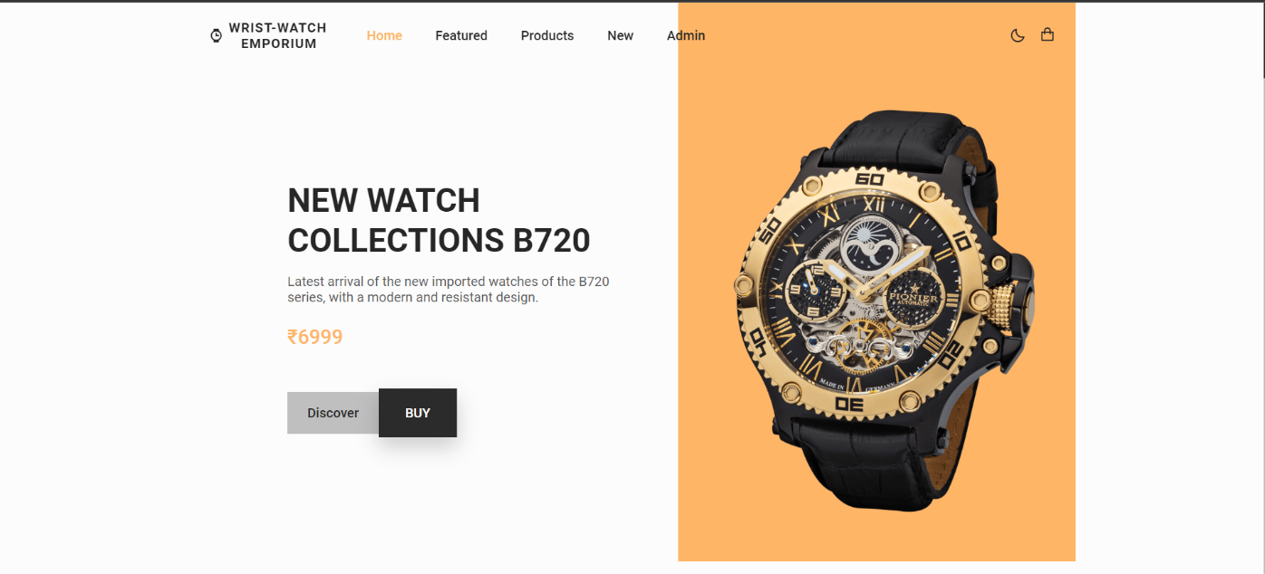

**3.2.2 User Login Interface**

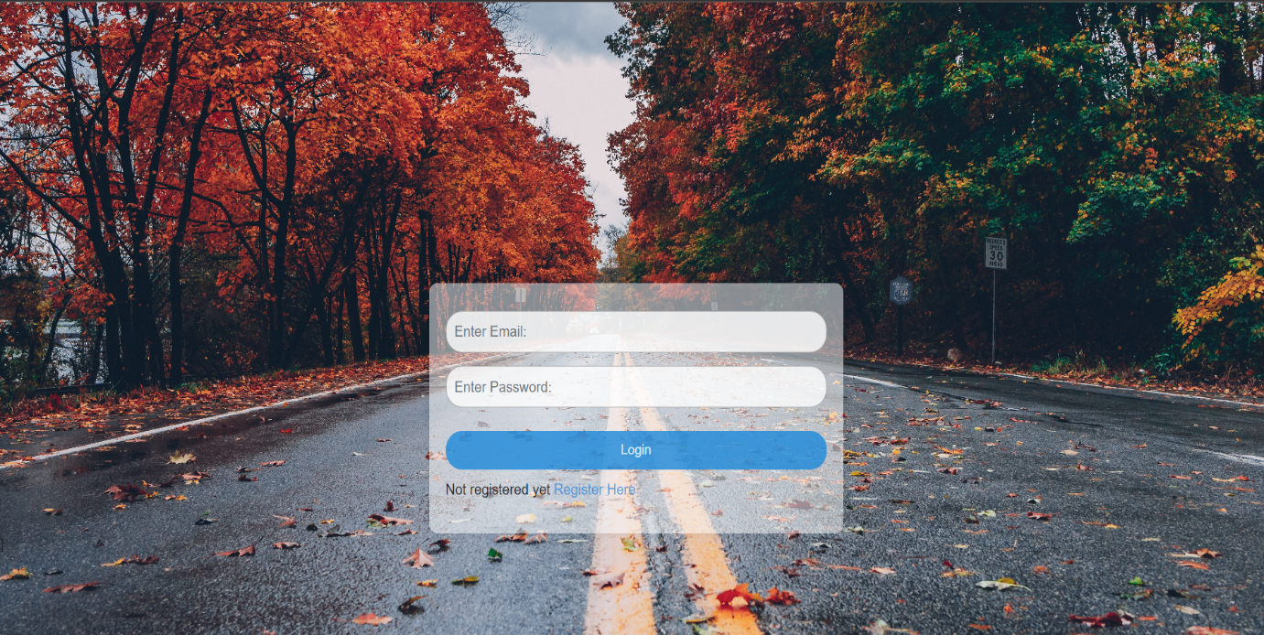

**3.2.3 User Registration Interface**

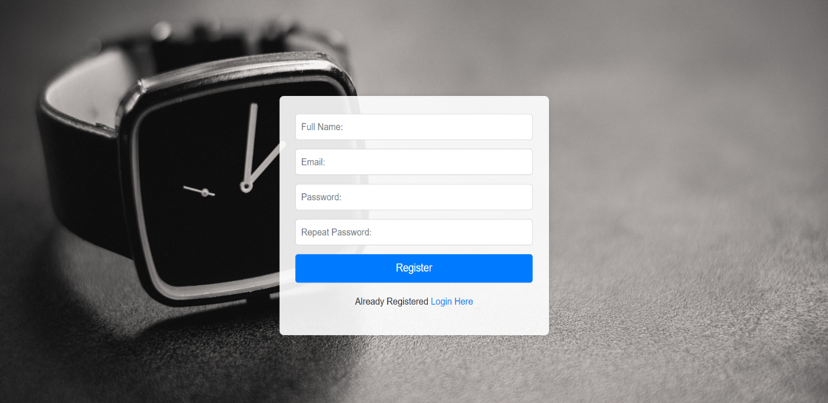

**3.2.4 User Logout Interface**

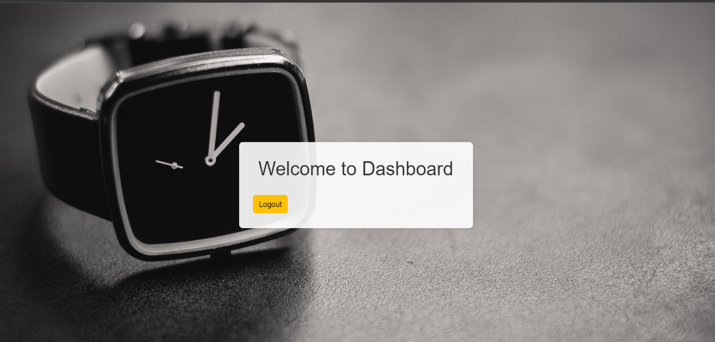

**3.2.5 Admin login Interface**

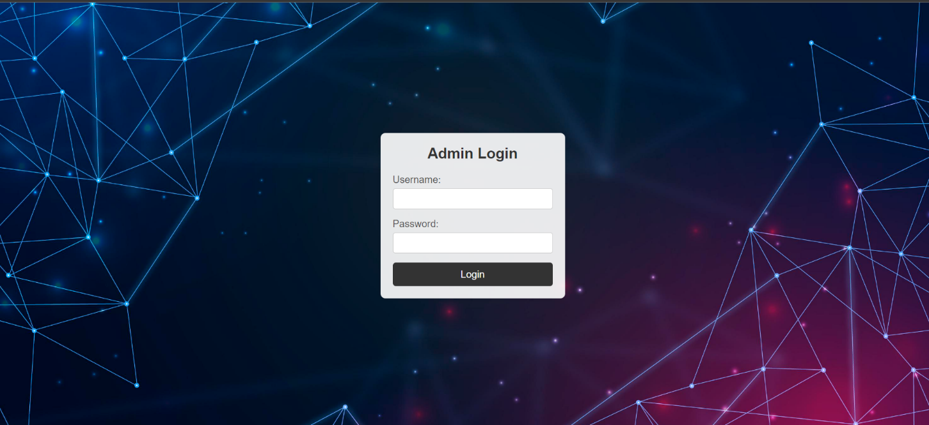

**3.2.6 Admin Dashboard**

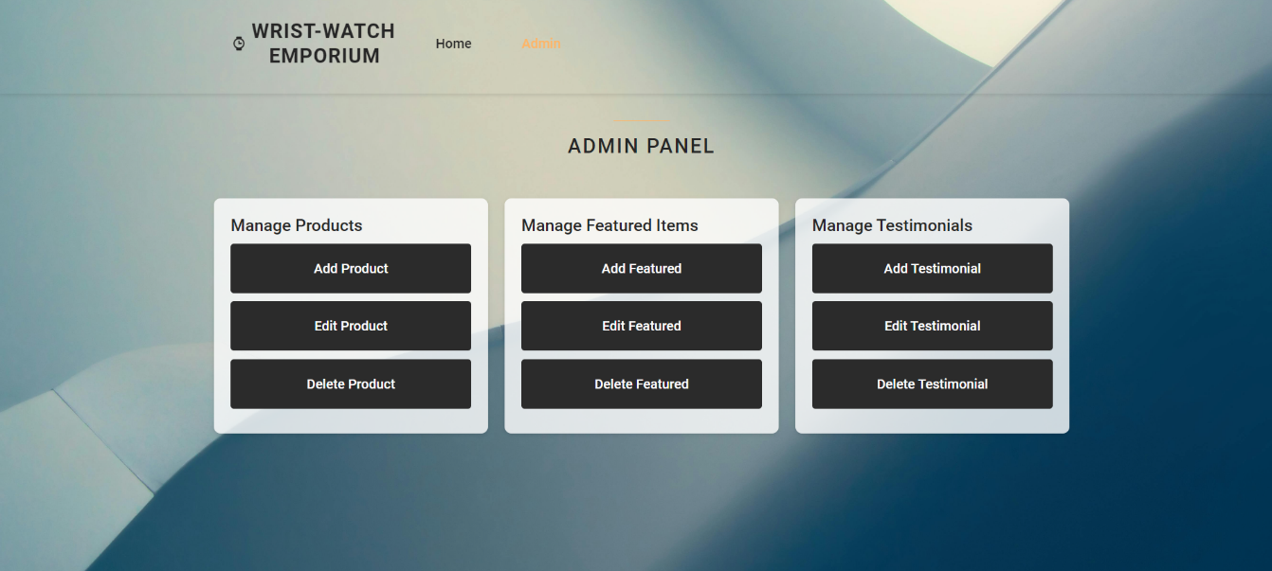

**3.2.7 Products**

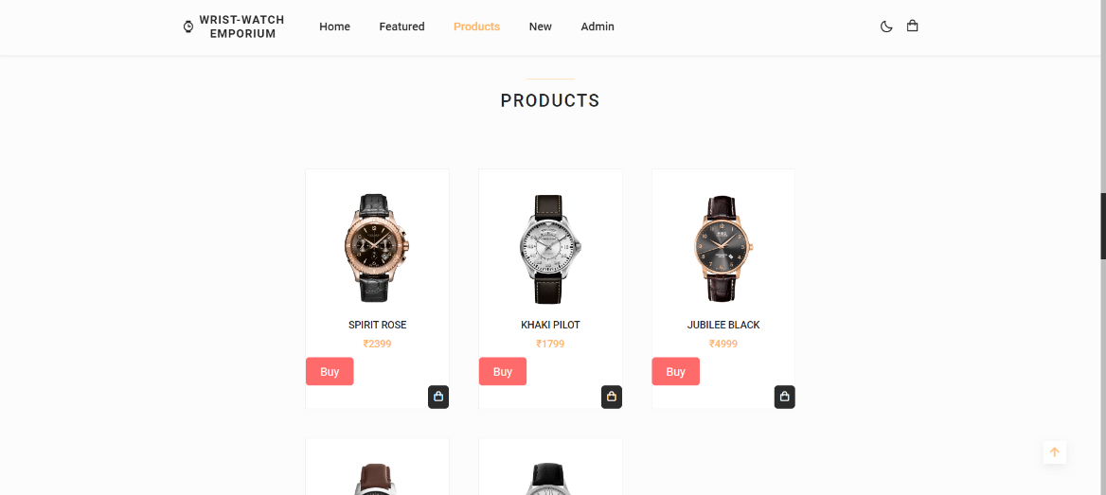

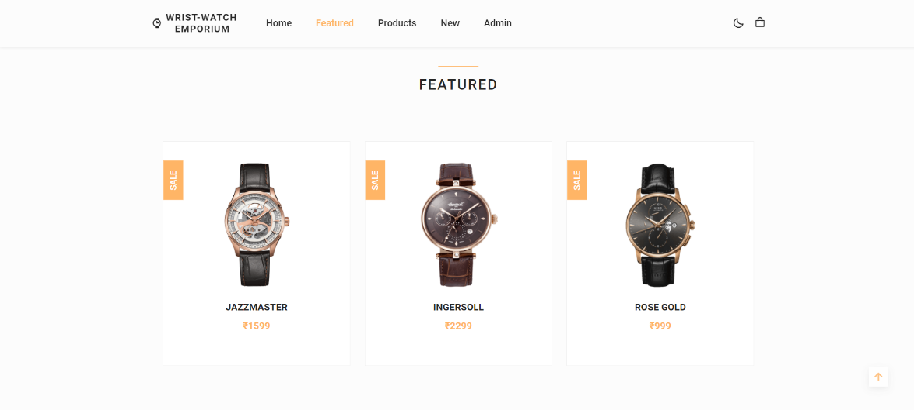

**3.2.8 Offers and About Us**

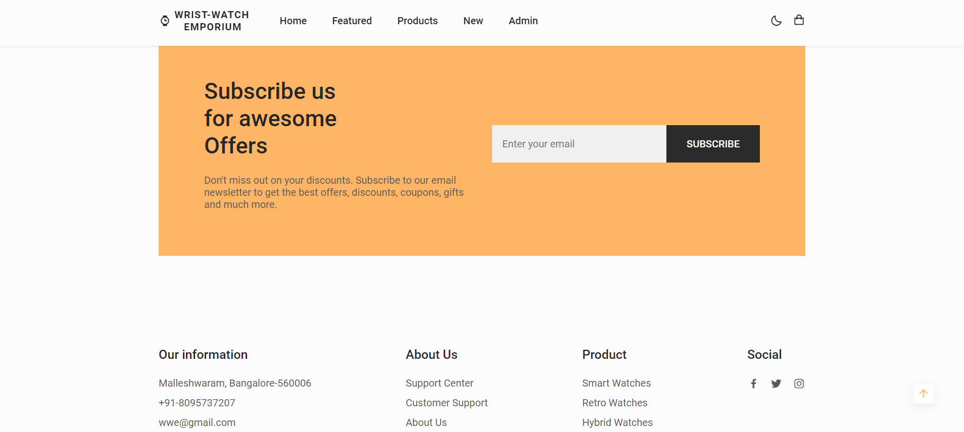

**3.2.9 Feedback**

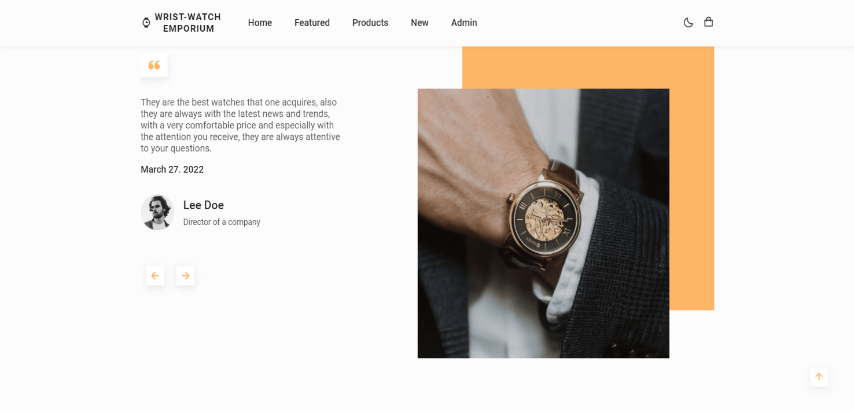

Chapter 4

Conclusion

* 1. **Major findings**

The primary target audience for the Wristwatch Emporium is males aged 25-45 with disposable income, showing strong preferences for both luxury watches and smartwatches. Luxury watches are valued for their craftsmanship and status, while smartwatches are favoured for their health and fitness tracking features.

In the competitive landscape, key players include luxury brands like Rolex and Omega and smartwatch brands such as Apple and Samsung. These competitors excel in brand recognition and product diversity but face challenges with high prices and limited customization options, providing opportunities for differentiation.

The product range will be categorized into luxury, smart, and fashion watches, with an emphasis on effective inventory management through just-in-time (JIT) practices to balance stock levels and minimize costs. This ensures a diverse yet efficiently managed product selection.

Sales strategies include seasonal discounts, flash sales, and first-time buyer incentives to attract and retain customers. A loyalty program offering points-based rewards and exclusive offers will encourage repeat purchases.

Customer service will be multi-channel, including live chat, email, and phone support, complemented by a comprehensive FAQ section. Clear return policies and warranty information will build trust and reduce purchase hesitation.

Performance monitoring via analytics will track key metrics like conversion rates and customer acquisition costs, using tools like Google Analytics and heatmaps. Continuous feedback will drive ongoing improvements.

Security and compliance are fundamental, with secure payment gateways and adherence to PCI DSS standards to protect customer data. Compliance with GDPR and other regulations will be ensured with clear privacy policies and marketing opt-in options.

The technical infrastructure must be robust, featuring reliable hosting for uptime and fast loading speeds, supported by Content Delivery Networks (CDNs) for global reach. Scalability is key to handling traffic spikes during promotions, ensuring a seamless shopping experience.

In summary, these findings highlight the need for a well-rounded approach encompassing market insights, competitive analysis, user-centric design, strategic marketing, robust customer service, and strong technical infrastructure to create a successful e-commerce platform for watches.

* 1. **Conclusion**

Wristwatch Emporium presents a valuable opportunity to enter a lucrative market with a diverse customer base. By offering a wide range of products—from luxury to budget-friendly options—the platform can appeal to various demographics. Key elements of success include a user-friendly interface, advanced technology such as AI-driven recommendations and virtual try-on features, and effective digital marketing strategies. Ensuring excellent customer service through multiple support channels, secure payment options, and efficient logistics further enhances customer satisfaction and trust. With continuous innovation and adaptation to market trends, the e-commerce site can achieve long-term success and become a preferred destination for watch enthusiasts worldwide.

* 1. **Limitations**
* **Inability for Physical Examination**: Customers cannot physically inspect or try on watches before purchasing, potentially deterring those hesitant about online shopping
* **Lack of Personalized Service**: Online platforms may struggle to provide the personalized service and expertise offered by brick-and-mortar stores, impacting customer satisfaction, especially among collectors seeking detailed information or advice.
* **Security Concerns**: Data breaches and fraudulent transactions pose significant risks. Ensuring the security of customer information and payment transactions is crucial to maintaining trust and credibility.
* **Logistical Issues**: Shipping delays, lost packages, and damage during transit can affect customer satisfaction. Dealing with international shipping, customs duties, and regulations adds complexity and cost to operations.
  1. **Suggestions / recommendations**
* **Curate a Unique Collection**: Offer a carefully selected range of watches, including popular brands and unique designs, to appeal to your target audience.
* **Optimize User Experience**: Ensure easy navigation, high-quality images, and clear product descriptions to streamline the shopping process.
* **Establish Trust**: Highlight authenticity, quality, and reliability through transparent policies and customer testimonials.
* **Mobile Optimization**: Make sure your website is mobile-friendly for seamless browsing and purchasing on all devices.
* **Targeted Marketing**: Use targeted marketing techniques like SEO, social media ads, and email campaigns to reach your ideal customers effectively.
  1. **Learning outcomes**

Developing an e-commerce website dedicated to watches has yielded several valuable learning outcomes. Firstly, the project underscored the importance of market research and understanding customer preferences within the watch industry. This knowledge was pivotal in curating a product range that appeals to various demographics, from luxury watch aficionados to budget-conscious shoppers. Secondly, the endeavor emphasized the significance of user experience optimization, highlighting the need for intuitive navigation, high-quality visuals, and detailed product information to facilitate seamless browsing and purchasing. Additionally, the project provided insights into building trust and credibility with customers, emphasizing transparency, authenticity, and reliable customer service as key pillars of success. Furthermore, the process of developing and implementing digital marketing strategies shed light on effective techniques for driving traffic, engaging with customers, and ultimately increasing sales. Finally, the project highlighted the importance of continuous improvement and adaptation in the rapidly evolving e-commerce landscape, emphasizing the need to stay abreast of industry trends, customer preferences, and technological advancements to maintain competitiveness and relevance in the market. Overall, the experience of creating an e-commerce website focused on watches has been a valuable learning journey, providing practical insights into various aspects of e-commerce operations, customer engagement, and business management.

* 1. **Abbreviations and Acronyms**
* HTML: Hypertext Mark-up Language
* PHP: Hypertext Pre-processor
* CSS: Cascading Style Sheet
* Ack: Acknowledgement
* EV: Electric Vehicle
* CFD: Context Flow Diagram
* DFD: Data Flow Diagram
* ER: Entity Relation

**4.7 References**

The Following are the books and references that we referred during the development period of the project.

1. "MySQL: The world's most popular open-source database" MySQL. (n.d.).

2. HTML:url” <https://www.w3schools.com/html/>”

3. CSS:url” <https://www.w3schools.com/css/>”

4. mongoDB” <https://www.mongodb.com/>”

5. Ecommerce Evolved: The Essential Playbook to Build, Grow & Scale a Successful Ecommerce Business by Tanner Larsson.

6. DotCom Secrets: The Underground Playbook for Growing Your Company Online by Russell Brunson